INFORMATION MANAGEMENT

**Exercise 6**

1. List all employees on the basis of the salary they draw.

SELECT * FROM employee_data ORDER BY salary;

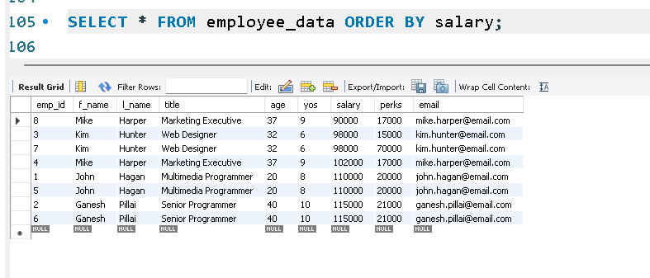

2. List all employees in descending order of their years of service.

SELECT * FROM employee_data ORDER BY yos DESC;

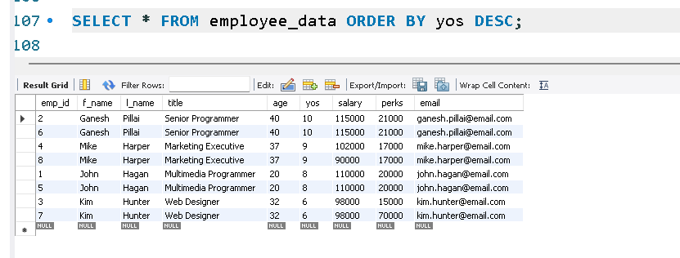

3. What does this statement display?

SELECT f_name, l_name FROM employee_data LIMIT 5;

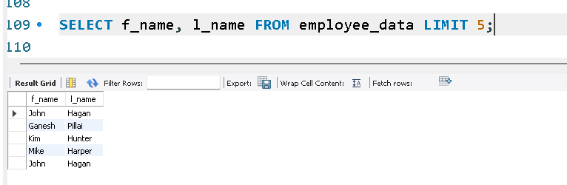

4. Display employees (last names followed by first names) who hold the title Programmer, Senior Programmer, or Web Designer and sort their last names alphabetically.

SELECT l_name, f_name FROM employee_data WHERE title IN ('Programmer', 'Senior Programmer', 'Web Designer') ORDER BY l_name;

